Subclass 482 (Skills in Demand / Temporary Skill Shortage)-STANDARD OPERATING PROCEDURE

Document Control
Document No. | SOP-SD-001
Version | 1.0
Department | Migration Services
Effective Date | ________________
Approved By | ________________

Purpose
This Standard Operating Procedure (SOP) establishes a consistent, efficient and compliant process for managing Subclass 482 (Skills in Demand) Visa applications from the initial employer enquiry through to the final visa outcome.
This SOP aims to:
- Standardize the Subclass 482 application process across the organization.
- Ensure compliance with Australian migration legislation and Department of Home Affairs requirements.
- Define the responsibilities of Registered Migration Agents and Consultants.
- Maintain accuracy, consistency and quality throughout the sponsorship, nomination and visa application process.
- Deliver professional and timely service to employers and nominated employees.
- Ensure all client records are securely maintained in accordance with the agency's Document Management Procedure.

2. Scope
his procedure applies to all Subclass 482 (Skills in Demand) Visa applications handled by Yale Migration.
The SOP covers:
- Initial employer enquiries
- Employer eligibility assessment
- Employee eligibility assessment
- Client engagement
- Employer consultation
- Standard Business Sponsorship (SBS) application (where required)
- Labour Market Testing (LMT)
- Nomination application
- Visa application
- Document collection and verification
- SBS lodgement
- Nomination lodgement
- Visa lodgement
- Post-lodgement monitoring
- Section 56 responses
- Visa outcome management

3. Roles and Responsibilities

3.1 Registered Migration Agent
The Registered Migration Agent is responsible for providing migration advice and ensuring compliance throughout the sponsorship, nomination and visa application process.

Responsibilities
- Assess employer eligibility.
- Assess employee eligibility.
- Identify migration risks.
- Conduct consultations with employers and nominated employees.
- Prepare Service Agreements.
- Prepare quotations.
- Assess whether a Standard Business Sponsorship (SBS) application is required.
- Review Labour Market Testing (LMT) compliance.
- Assess the nominated occupation and applicable Core Skills Income Threshold (CSIT) requirements.
- Review employment contracts and salary compliance.
- Prepare or review the Standard Business Sponsorship (SBS) application.
- Prepare or review the Nomination application.
- Review the Skills in Demand Visa application.
- Conduct final quality assurance before lodgement.
- Lodge SBS, Nomination and Visa applications through ImmiAccount.
- Monitor application progress.
- Respond to Department requests, including Section 56 requests.
- Provide post-decision advice to employers and employees.

3.2 Consultant
The Consultant is responsible for coordinating client communication, documentation and administrative support throughout the application process.

Responsibilities
- Respond to employer and employee enquiries.
- Collect preliminary information.
- Conduct the initial client screening.
- Endorse eligible enquiries to the Registered Migration Agent.
- Send employer and employee document checklists.
- Register clients in the Client Management System.
- Generate Unique Client Codes.
- Create electronic client folders.
- Coordinate document collection.
- Review documents for completeness.
- Prepare supporting documentation for SBS, Nomination and Visa applications.
- Follow up outstanding documents.
- Monitor application progress.
- Provide regular updates to employers and employees.
- Prepare invoices.
- Update internal tracking systems.
- Upload documents into ImmiAccount after approval from the Registered Migration Agent.
- Maintain complete and accurate client records.

4. Tools and Systems
The following systems are used throughout the Subclass 482 application process:
- ImmiAccount
- Client Management System
- Client Engagement Log
- Secure Cloud Document Storage
- Employer Checklist
- Employee Checklist
- Standard Business Sponsorship Checklist
- Labour Market Testing Checklist
- Nomination Checklist
- Visa Application Checklist
- Microsoft Office / Google Workspace
- Department of Home Affairs Legislative Instruments
- Skills in Demand Occupation List Reference
- CSIT Salary Reference Guide

5. Document Management

Every client must be registered in the Client Engagement Log to generate a Unique Client Code

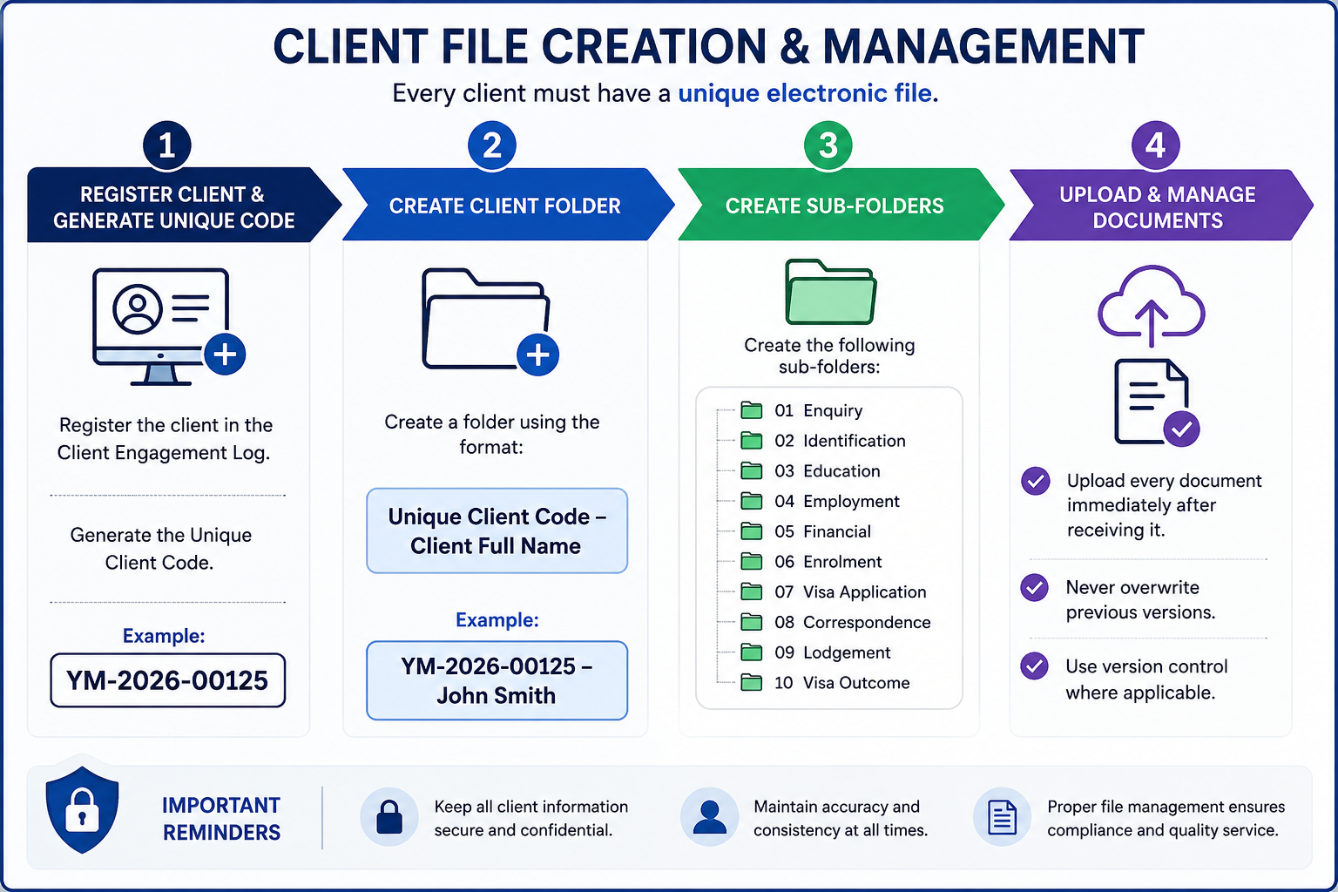

Step | Process | Procedure
1 | Register Client | Register the client in the Client Engagement Log and generate a Unique Client Code.  Example: YM-2026-00125
2 | Create Client Folder | Create a client folder using the following naming convention:  Unique Client Code – Client Full Name  Example: YM-2026-00125 – John Smith
3 | Create Sub-Folders | Create the following folders within the client's main folder:  01. Enquiry  02. Identification  03. Education  04. Employment  05. Financial  06. Enrolment  07. Visa Application  08. Correspondence  09. Lodgment  10. Visa Outcome
4 | Upload & Maintain Documents | Upload all client documents immediately upon receipt.  • Do not overwrite previous versions.  • Apply version control where necessary.  • Ensure all documents are saved in the correct sub-folder.

6. Subclass 482 (Skills in Demand Visa) Application Procedure

Step | Process | Responsible | Required Action
1 | Receive Enquiry | Consultant | Respond to employer or employee enquiries via phone, email, social media or walk-in. Obtain preliminary information regarding the employer, business and nominated employee.
2 | Initial Assessment | Consultant | Request the completed enquiry form, employer details, employee resume, passport, current visa (if applicable), and relevant employment information.
3 | Eligibility Assessment | Registered Migration Agent | Assess the eligibility of both the employer and nominated employee under the Skills in Demand Visa requirements. Identify any migration or compliance risks.
4 | Employer & Employee Consultation | Registered Migration Agent | Conduct a detailed consultation explaining the sponsorship process, visa requirements, Labour Market Testing (LMT), occupation requirements, salary requirements, visa conditions, government fees, professional fees and expected processing times.
5 | Client Engagement | Consultant | Register the employer and employee in the Client Engagement Log, generate Unique Client Codes, create electronic folders, and send the quotation, Service Agreement and document checklists.
6 | Service Agreement & Initial Payment | Consultant | Obtain the signed Service Agreement and confirm receipt of the engagement fee before commencing the application.
7 | Document Collection | Consultant | Collect all required employer and employee documents in accordance with the agency's document checklists.
8 | Document Verification & Storage | Consultant | Review documents for completeness and upload them into the electronic client folder following the Document Management Procedure.
9 | Standard Business Sponsorship (SBS) Assessment | Registered Migration Agent | Determine whether the employer already holds an approved Standard Business Sponsorship (SBS). If not, prepare the SBS application.
10 | Labour Market Testing (LMT) Assessment | Registered Migration Agent | Review Labour Market Testing evidence to ensure it complies with current legislative requirements. Advise the employer if additional advertising is required.
11 | Occupation & Salary Assessment | Registered Migration Agent | Confirm that the nominated occupation is eligible and that the proposed salary meets the Core Skills Income Threshold (CSIT), Annual Market Salary Rate (AMSR), and all legislative requirements.
12 | Standard Business Sponsorship (SBS) Application (if required) | Registered Migration Agent | Prepare and lodge the Standard Business Sponsorship application through ImmiAccount.
13 | Nomination Application Preparation | Registered Migration Agent | Prepare the Nomination application, ensuring all employer documents, Labour Market Testing evidence, employment contract and salary information are complete.
14 | Nomination Review & Lodgement | Registered Migration Agent | Conduct a final review and lodge the Nomination application through ImmiAccount.
15 | Visa Application Preparation | Consultant | Prepare the Subclass 482 Visa application, upload supporting documents and complete the ImmiAccount draft.
16 | Client Review & Approval | Consultant | Send the completed visa draft to the nominated employee for review and obtain written confirmation that all information is accurate before lodgement.
17 | Final Review & Visa Lodgement | Registered Migration Agent | Perform the final quality assurance review and lodge the Visa application through ImmiAccount.
18 | Update Internal Records | Consultant | Update the Lodgement Register with the SBS (if applicable), Nomination and Visa Transaction Reference Numbers (TRNs), lodgement dates and Bridging Visa details (if applicable).
19 | Post-Lodgement Communication | Consultant | Forward the visa lodgement acknowledgement, Bridging Visa Grant (if applicable), HAP ID, health examination instructions and any other relevant post-lodgement information to the nominated employee and employer.
20 | Application Monitoring | Consultant / Registered Migration Agent | Monitor the SBS, Nomination and Visa applications through ImmiAccount. Respond promptly to Department requests, including Section 56 Requests for Further Information.
21 | Visa Outcome | Registered Migration Agent / Consultant | Notify the employer and nominated employee of the visa outcome. For granted applications, explain visa conditions and employer obligations. For refused applications, explain the decision and discuss available options.
22 | File Closure | Consultant | Save all final correspondence, update the Client Engagement Log and Lodgement Register, and archive the employer and employee files in accordance with the agency's Document Management Procedure.

Internal Quality Control Points
Before lodging any application, ensure the following:
- Employer eligibility confirmed
- Standard Business Sponsorship (SBS) status verified
- Labor Market Testing completed and compliant
- Occupation eligibility confirmed
- Salary meets CSIT and AMSR requirements
- Employment contract reviewed
- Employer documents verified
- Employee documents verified
- Nomination approved for lodgment
- Visa application reviewed by the Registered Migration Agent
- Client approval received
- Government fees confirmed
- All documents uploaded to ImmiAccount
- Internal records updated

7. Quality Control Checklist
The Registered Migration Agent must complete the following quality assurance checks before lodging any Subclass 482 (Skills in Demand) Visa application. No application is to be lodged until all applicable items have been reviewed and confirmed.
Quality Check | Completed (✓)
Employer identity has been verified, and the business is lawfully operating. | ☐
Employer eligibility has been assessed and confirmed. | ☐
Standard Business Sponsorship (SBS) status has been verified or a new SBS application has been prepared (if required). | ☐
Labor Market Testing (LMT) has been completed and complies with current legislative requirements. | ☐
Nominated occupation is eligible under the current Skills in Demand Visa occupation list. | ☐
Proposed salary meets the Core Skills Income Threshold (CSIT) and the Annual Market Salary Rate (AMSR) requirements. | ☐
Employment contract has been reviewed and complies with Australian workplace and migration requirements. | ☐
Employer declaration and supporting business documents have been reviewed and verified. | ☐
Employee identity has been verified using a valid passport or government-issued identification. | ☐
Passport is valid for the intended visa application period. | ☐
Employee meets the required qualifications, skills and work experience for the nominated occupation. | ☐
Skills Assessment has been obtained where required by legislation or the nominated occupation. | ☐
English language requirement has been met and valid evidence has been provided (where applicable). | ☐
Health insurance requirements have been confirmed (where applicable). | ☐
Police Clearance Certificates have been obtained where required. | ☐
All supporting documents have been reviewed for completeness, accuracy and consistency. | ☐
Employer and employee information is consistent across all forms, declarations and supporting documents. | ☐
All required forms, declarations and consent documents have been completed and signed. | ☐
Employer and employee have reviewed and approved the final application before lodgment. | ☐
Government fees, professional fees and all applicable third-party costs have been confirmed with the client. | ☐
All supporting documents have been correctly named, organized and saved in accordance with the Document Management Procedure. | ☐
Registered Migration Agent has completed the final compliance review and approved the application for lodgment. | ☐
SBS Application (if applicable), Nomination Application and Visa Application have been successfully lodged through ImmiAccount. | ☐
Transaction Reference Numbers (TRNs), lodgment confirmations and all post-lodgment records have been saved in the client file. | ☐

Important
- Any missing, inconsistent or incomplete information must be resolved before lodging the application.
- Labor Market Testing (LMT) must fully comply with current legislative requirements before the nomination application is lodged.
- The Registered Migration Agent must verify that the employer satisfies all sponsorship obligations and that the nominated employee meets the visa eligibility requirements.
- Any Request for Further Information (Section 56) issued by the Department of Home Affairs must be actioned before the specified due date.
- The Registered Migration Agent is responsible for ensuring that the SBS (where applicable), Nomination and Visa applications comply with current Australian migration legislation, Department of Home Affairs policy and professional obligations before lodgment.

8. Compliance and Disclosure
Yale Migration is committed to maintaining the highest standards of professionalism, ethical conduct and compliance with Australian migration legislation.
All staff involved in Graduate Visa applications must comply with the following requirements:

Legislative Compliance
- Comply with all applicable Australian migration legislation, regulations and policy requirements.
- Follow all requirements of the Department of Home Affairs when preparing and lodging visa applications.
- Ensure that all information provided in a visa application is accurate, truthful and supported by appropriate evidence.

Professional Responsibilities
- Only a Registered Migration Agent may provide migration advice or make legal representations regarding visa matters.
- Consultants and administrative staff must not provide migration advice unless authorised to do so.
- Any complex migration issues must be referred to the Registered Migration Agent.

Client Confidentiality
- Protect all client information in accordance with Australian privacy requirements and the agency's privacy policy.
- Client information must only be accessed by authorized staff for legitimate business purposes.
- Client documents must be stored securely within the agency's approved document management system.

Accuracy and Record Management
- Maintain complete, accurate and up-to-date client records always.
- Record all client communications, advice provided, and documents received or submitted.
- Ensure all electronic files follow the agency's document naming and filing procedures.

Fee Disclosure
Before commencing any work, the client must receive clear written information regarding:
- Professional service fees.
- Government Visa Application Charges (VAC).

Client Acknowledgement
Before visa lodgment, the client must acknowledge that:
- All information provided is true, complete and accurate.
- They have reviewed and approved the final visa application.
- They understand their obligations as a Student Visa holder.
- They understand that providing false or misleading information may result in visa refusal or cancellation.

Visa Outcome Disclaimer
Yale Migration will prepare and manage every application with due skill, care and diligence. However, the approval or refusal of any visa application is solely at the discretion of the Department of Home Affairs.
Neither Yale Migration nor the Registered Migration Agent can guarantee the grant of a visa, as each application is assessed on its individual merits and in accordance with Australian migration legislation and policy.

